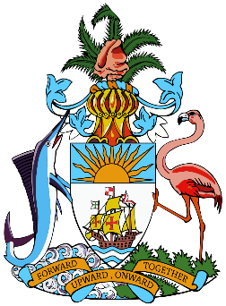 The Diplomatic Beat  3rd Quarter Edition

**April-June 2018**

**Staff Featured**

Overseas Office- Bahamas Atlanta Consulate

Head of Mission: Ambassador Quant

Faces in the Ministry- AC Antonio Butler/ Consular Staff Member

**Featured Stories**

Office of The Spouse

Anastacia Minnis Experience on course in Chile

**Staff Relations Section**

RIP to Ms. Denise Mcsweeny

Condolences to Ms. Conliffe on the passing of her mother

Officers recently deployed- Rosolyn Rodgers, Donna Lowe, Raylene Ferguson, Ieshia Deveaux, Allene Ambrose and Gaynell Evans, Nestor Sands, Mavis Vanderpool

Officers recently returned- Craig Powell, Deborah Saunders, Deandra Cartwright

**Welcome**

Dr. Kenya Ward

Captain Godfrey Williams

**Highights from the Quarter**

CHOGM

Summit of the Americas

OAS GA

COFCOR

38th Human Rights Council

Presentations of Credentials (Norway, France and Nigeria)

**Upcoming Events**

Candidatures

Diplomatic Week

UNGA

Staff Directory of overseas missions i.e (name, position and email address)